Effect of Water Shortages in Farming
Name of Student
Name of Institution
Date
The purpose of this documentary is to illuminate on the hardships brought about by lack of water mostly on farming. The video does not make use of pictures to illustrate metaphors. The illustration chosen for this purpose shows a running water body which is not at its full capacity. Just at the edge of the river to the extreme left, a plantation can be sited but the rest of the illustration is covered dry wasteland even with the presence of a river. The illustration is used in support of the documentary purposes (Rohrbach, et al., 2013). The wasteland shows the looming crisis of lack of water which seems not to be addressed. The wasteland also shows some pieces of land cleared and set aside for farming on the valley. These areas set aside face the challenge of distance from the river, which shows why the plantation just beside the river blossoms. The river itself is not at full capacity which also presents a challenge.
On the extreme right of the shows grass that has dried out which shows that once the land could cater for the grass. The documentary depicts a clear sense of the culture of farming. The dried grass on the image indicates the onset of a drought and the stripped land just behind the grass would indicate a land stripped of plantation (permanent trees) to set the course for more resistant crops. Stereotypes in the documentary levy heavy costs of water to these areas since they are under populated and underrepresented in the legislature but favor supplying water at cheaper costs to populate areas like Washington. The stereotypes also seem convinced that such land isn’t an immediate concern and that rainfall in the winter and El Nino could fix such state of affairs. The image challenges these notions mostly since the area is reported not to have witnessed rainfall in 2 years. Water is a basic necessity for every population, and mostly to farmers since water is a necessity for crops to grow. The wasteland and the onset of drought would lead to poverty for the farmers and the nation. The image would have painted the sensation with the illustrations of dust from cyclones.
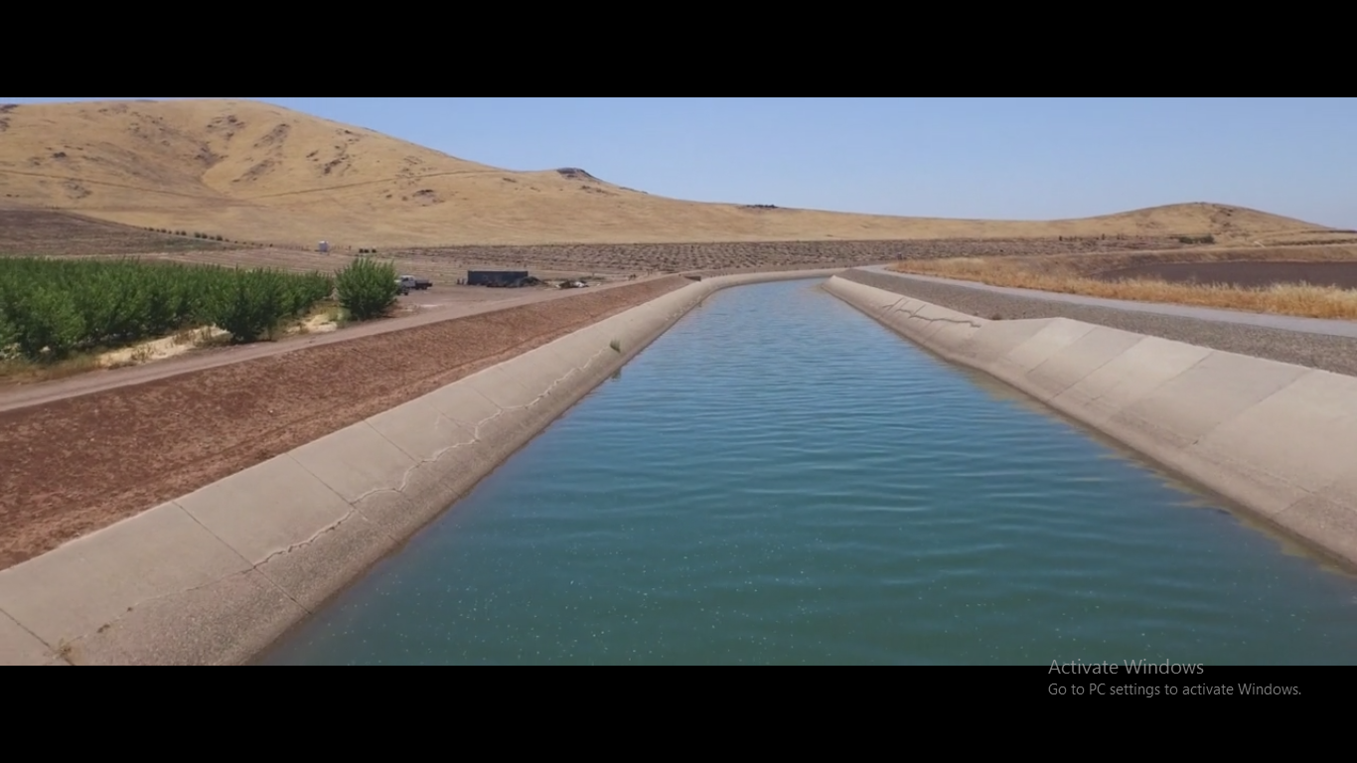

References
Rohrbach, M., Qiu, W., Titov, I., Thater, S., Pinkal, M., & Schiele, B. (2013). Translating video content to natural language descriptions. Proceedings of the IEEE International Conference on Computer Vision, 43-440.
https://vimeo.com/145322081

